Pratical no:2
Code:
print("----------student details-------")
name=(input("Enter your name:"))
age=0
age=(input("Enter your age:"))
if age<=17 and age>=25:
print("it is elgibal")
else:
print("it is not elgibal")

mark=input("enter your mark")
mark=0
if mark>=90:
print("allow seat in aiml",mark)
elif mark>=80:
print("allow seat in cse",mark)
else :mark>=60
print("allow seat in genral",mark)

Output:
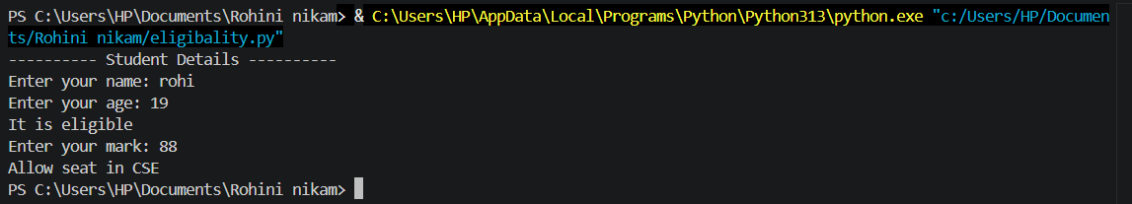

Exercise

Q .01: Develop a screening program that checks a user's age and income status to see if they qualify for a specialized education scholarship scheme. The rules state that the applicant must be under 25 years old and have an annual family income below ₹3,00,000.

Code:
age = int(input("Enter your age: "))
income = int(input("Enter annual family income: ₹"))

if age < 25 and income < 300000:
print("Congratulations! You qualify for the specialized education scholarship.")
else:
print("Sorry! You do not qualify for the scholarship.")

Output:

Q.02:Create a system validator that evaluates a candidate's placement eligibility by verifying they have a graduation score of 70% or more and no active academic backlogs.

Code:

score = float(input("Enter graduation score (%): "))
backlogs = int(input("Enter number of active backlogs: "))

if score >= 70 and backlogs == 0:
print("Congratulations! You are eligible for placement.")
else:
print("Sorry! You are not eligible for placement.")

Output:

